MSU Extension’s Six-Step Community Change Model

Step 3: Explore What’s Working

Step 3 Guide: Explore What’s Working
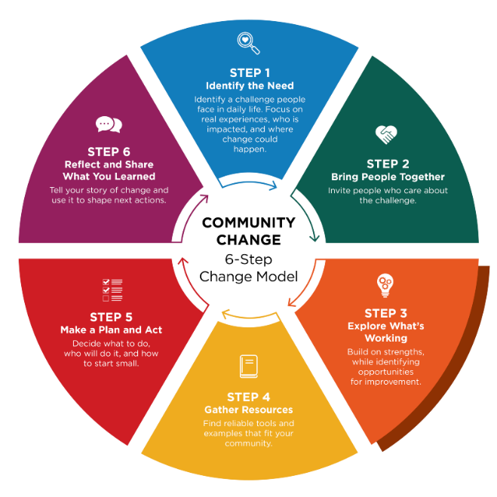
Community Champions contribute insight into what has worked before, ground options with real needs, and help define what matters most to the community.

Before choosing your next steps, it helps to understand what things look like right now and what has worked well in the past in your community or other communities. This means paying attention to what is already helping, what has been successful, and what might be getting in the way. When you understand current conditions, you can make thoughtful decisions about where change would be most useful.

Look at everyday practices and spaces
With your partners, take time to observe the setting, talk through routines, and think about the places where people spend time. This helps you notice strengths, gaps, and opportunities for improvement.
You may find it helpful to keep a list of guiding questions on hand during your discussion. Questions like these can get the conversation started:

- What’s working well—and what has worked well in the past—that we can build on?
- Are there current practices we could improve?
- Where do people feel stuck or frustrated?
- Are there patterns or gaps that seem important to address?
- Are there opportunities to make healthy choices easier?
- What changes have you already been thinking about?
- Is there anything in the data that supports the direction you’ve been considering?
- What would make the biggest difference for clients, students, or the community?

Consider readiness for change

It is also important to think about what nutrition and physical activity changes you are ready to act on. Readiness includes confidence, motivation, capacity, and feeling supported. When people feel ready, changes are more likely to stick.

By understanding both what’s happening at your site currently and how ready your team is, your team can choose the next steps that feel realistic, meaningful, and doable for the group.

Use tools or structured approaches when helpful

In some situations, tools can help organize the conversation. For example, Appreciative Inquiry is a process that focuses on what is going well and how to build on those strengths. In other cases, simply having a goal-oriented discussion or walking through the setting together can help people notice what could improve. Choose an approach that helps people feel comfortable sharing ideas and noticing possibilities.

Step 3 Worksheet: Explore What’s Working

During conversations with the group, it may be useful to capture their perspective on:
- What’s working right now or has worked?
- What feels true about the current situation?
- What you hope things could look like in the future?
- What might make it hard to get there?

Community Champions help ground insights into lived experience and support facilitation.

Activity

Write each of the four headings (see below) on large sheets of paper and post them around the room. Give each person sticky notes and ask them to write one idea per note. Then have them place their notes under the heading that best fits their idea. After all the notes are posted, read them out loud together. If something isn’t clear, ask the person who wrote it to explain. You can also group similar ideas to see patterns. If helpful, a neutral facilitator can guide the conversation and make sure all voices are heard. MSU Extension is available to support community groups through visioning and action planning.

Community champion contribution

- Community Champion shares context on prior efforts
- Community Champion helps connect ideas and voices
- Community Champion ensures perspectives of those most affected are included

About MSU Extension’s Community Change Model
This Guide and Worksheet is part of a larger Six-Step Community Change Model Toolkit that assists community champions in supporting communities to make thoughtful, lasting improvements that help people choose nourishing foods and stay active. Six simple steps guide desired change efforts by bringing people together, taking action, and sharing what was learned along the way.
See MSU Extension’s Community Change Hub for curated resources and topic-specific guidance that support change efforts related to championing school wellness, food access, early childhood health, and active communities.

